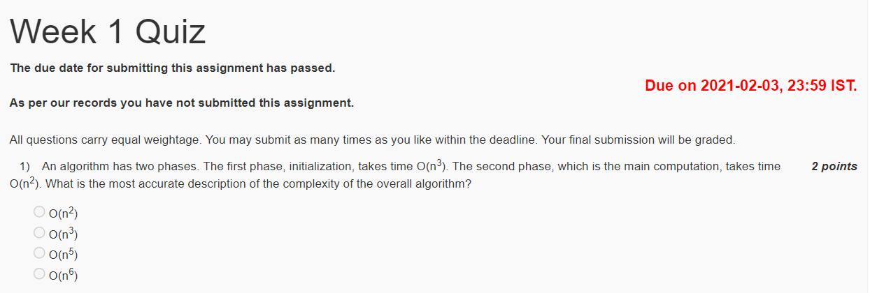

Ans - O(n3)

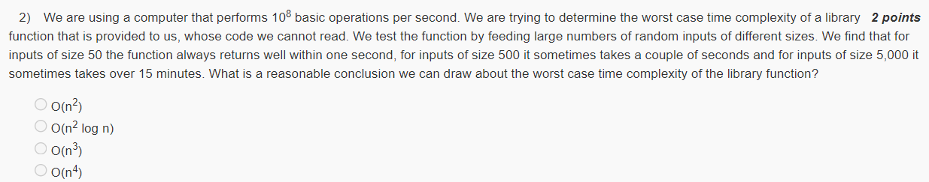

Ans - O(n3)

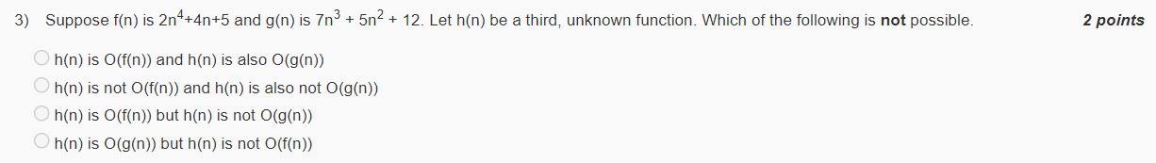

Ans - h(n) is O(g(n)) but h(n) is not O(f(n))

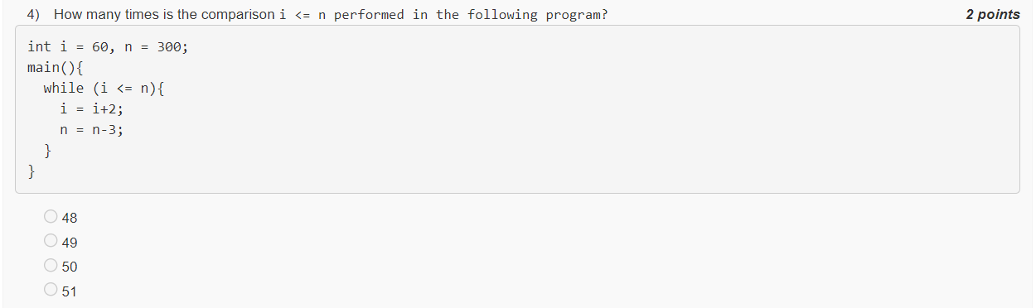

Ans - 50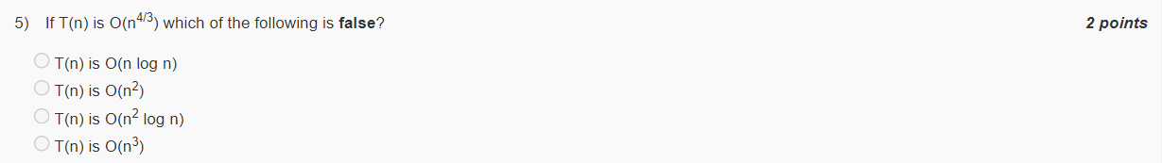

Ans - n1/3 is not O(log n)

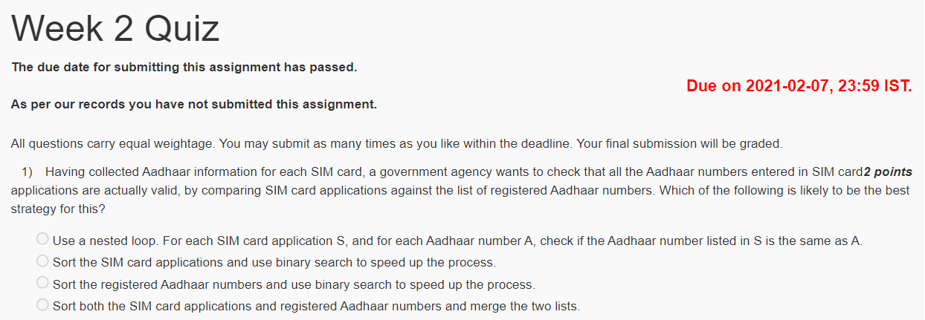

Ans - Sort the registered Aadhaar numbers and use binary search to speed up the process.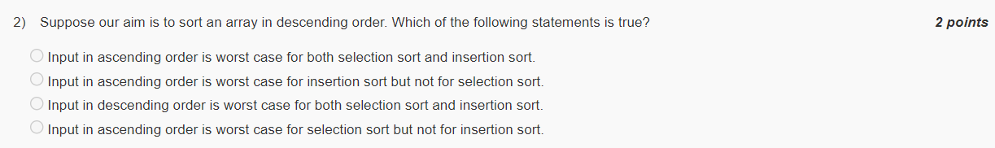

Ans - Input in ascending order is worst case for both selection sort and insertion sort.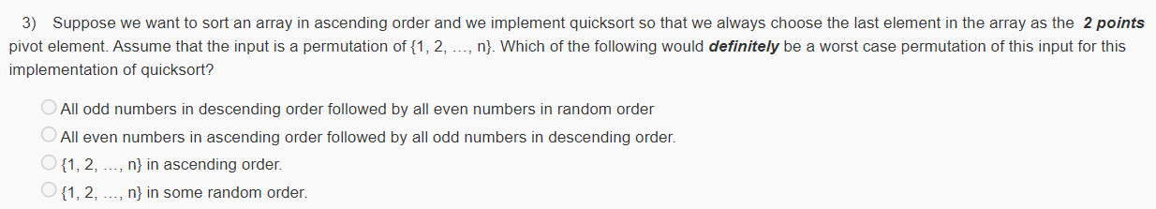

Ans - {1, 2, …, n} in ascending order

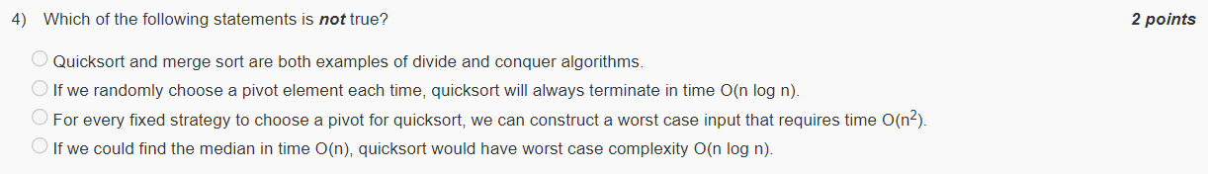

Ans - If we randomly choose a pivot element each time, quicksort will always terminate in time O(n log n).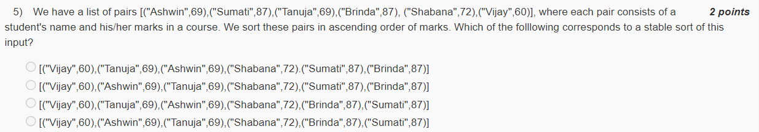

Ans - [("Vijay",60),("Ashwin",69),("Tanuja",69),("Shabana",72),("Sumati",87),("Brinda",87)]

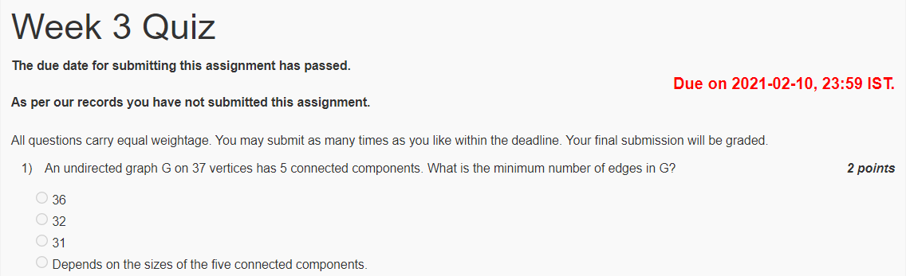

Ans - 32 edges.

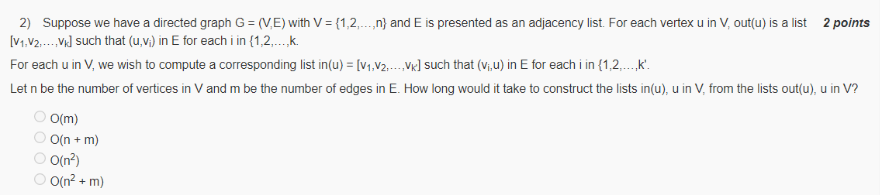

Ans - O(n2+m)

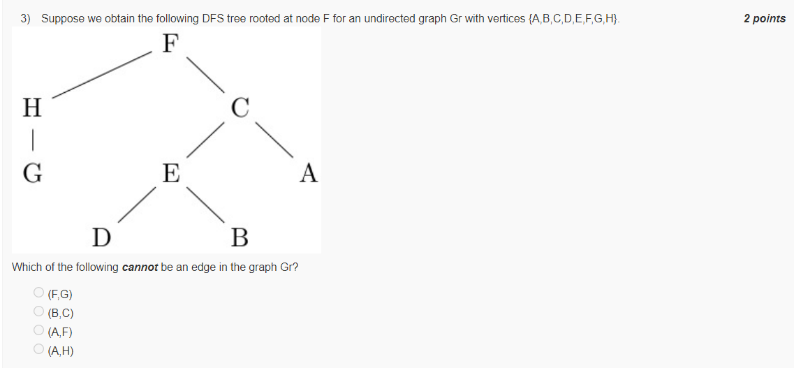

Ans - (A,H)

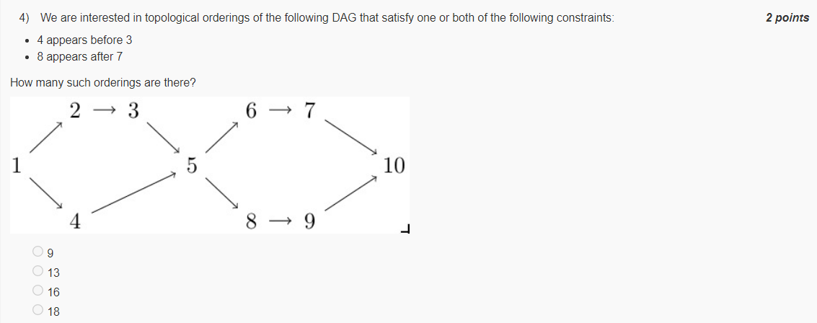

Ans - 13

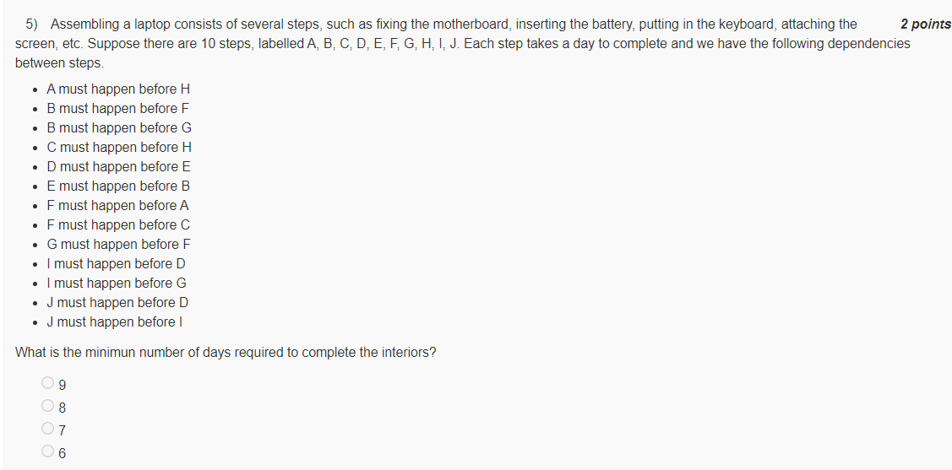

Ans – 8

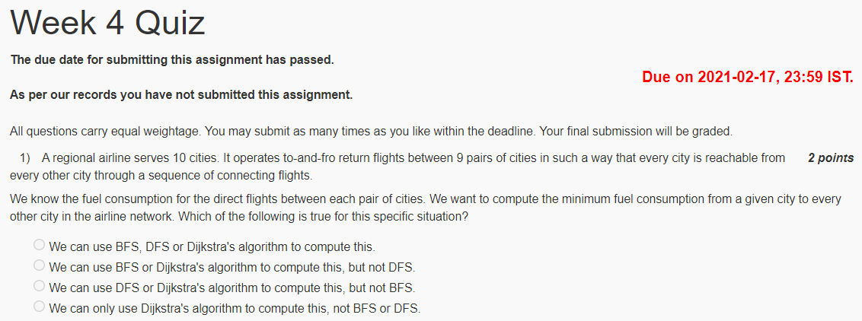

Ans - We can use BFS, DFS or Dijkstra's algorithm to compute this.

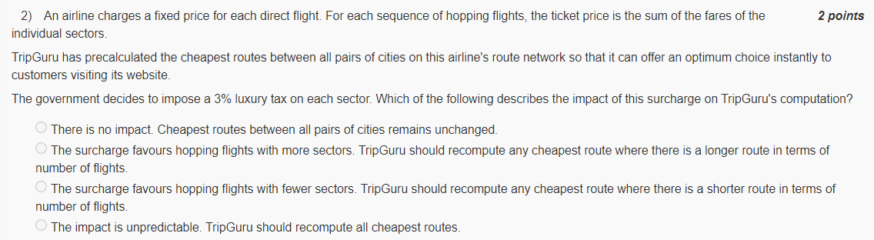

Ans - There is no impact. Cheapest routes between all pairs of cities remains unchanged.

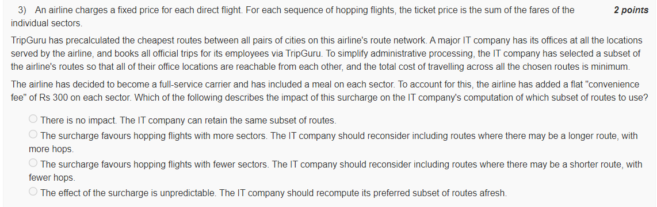

Ans - There is no impact. The IT company can retain the same subset of routes.

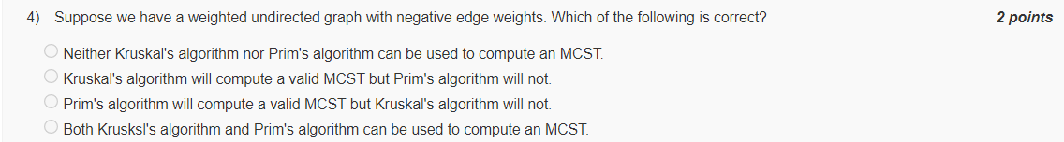

Ans - Both Krusksl's algorithm and Prim's algorithm can be used to compute an MCST.

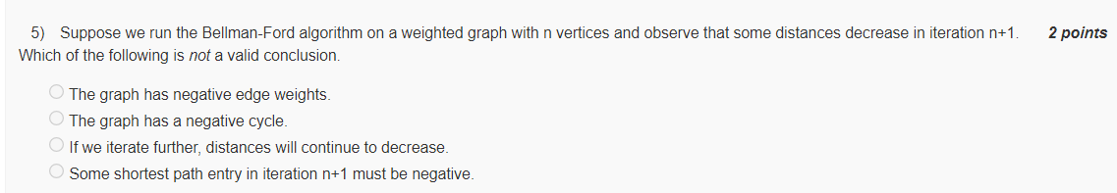

Ans - Some shortest path entry in iteration n+1 must be negative.

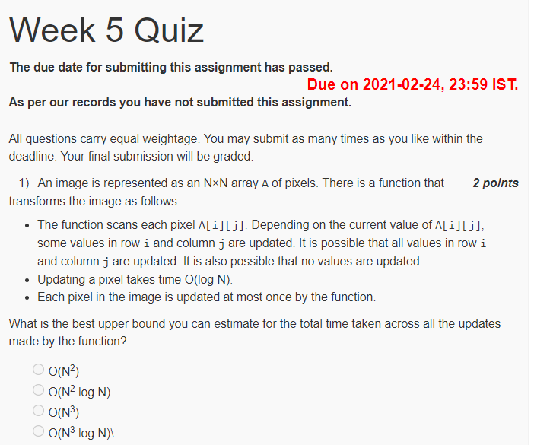

Ans - O(N2 log N)

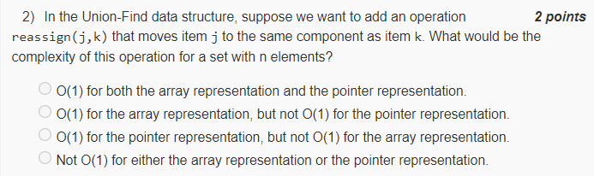

Ans - Not O(1) for either the array representation or the pointer representation.

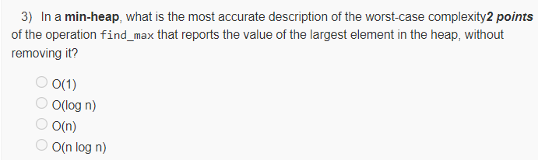

Ans - O(n)

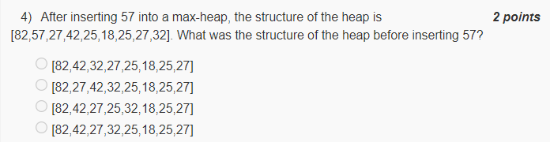

Ans - [82,42,27,32,25,18,25,27]

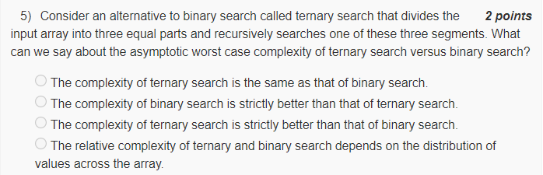

Ans - The complexity of ternary search is the same as that of binary search  
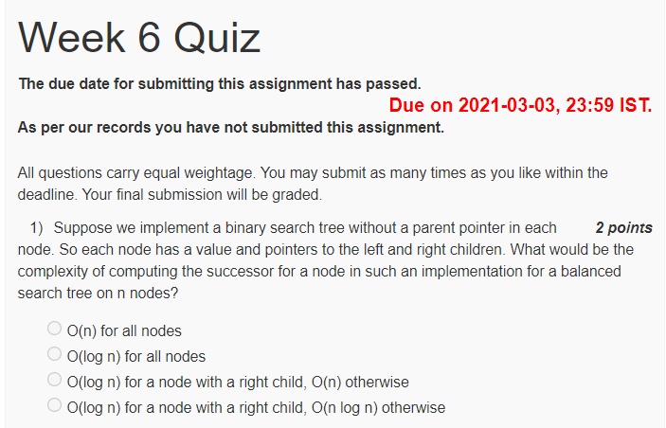

Ans - O(log n) for all nodes

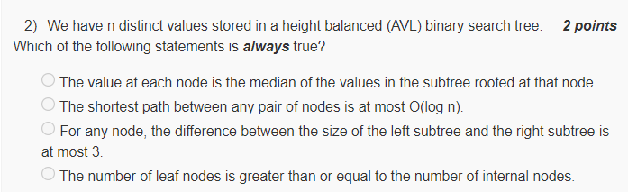

Ans - The shortest path between any pair of nodes is at most O(log n).

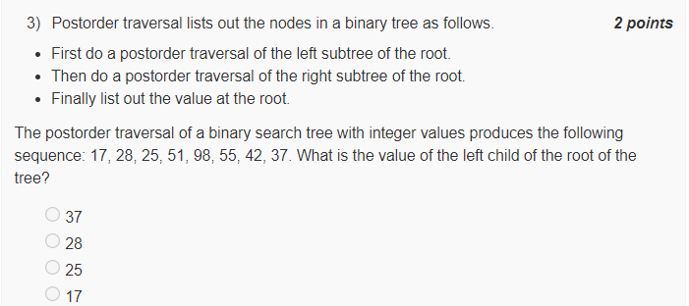

Ans - 25

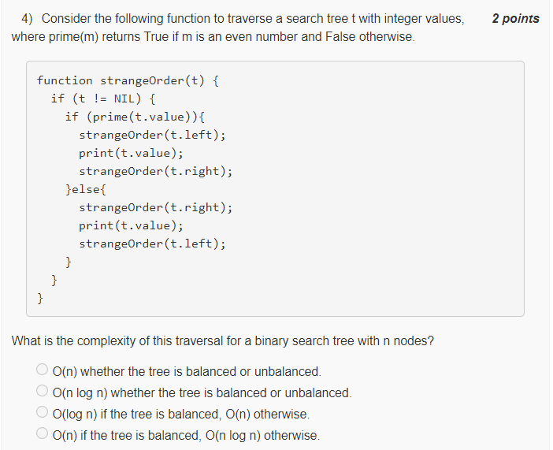

Ans - O(n) if the tree is balanced, O(n log n) otherwise

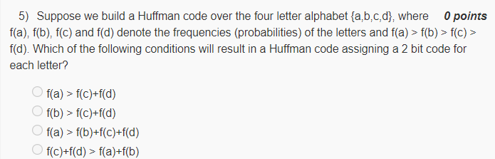

Ans - f(c)+f(d) > f(a)+f(b)

Ans - max(Profit[i+1], Profit[i+2] + Price[i+1] - Price[i] - 2, Profit[i+3] + Price[i+2] - Price[i] - 2, ... Profit[N] + Price[N-1] - Price[i] - 2, Price[N] - Price[i] - 2)

Ans - N

Ans - From Profit[N] to Profit[1]

Ans - O(N2)

Ans - 8

Ans - 3x ≥ 14y + 2z + 13  
  
Ans - Assign each edge capacity 1 and check that the maximum flow is at least 3.

Ans - Find a minimal size decomposition into connected components

Ans - There is a polynomial time reduction from SAT to B, and B has a checking algorithm.

Ans - if we have a polynomial time algorithm for A, we must also have a polynomial time algorithm for B